**Understanding of Binary numbers:**

## **Denary Numbers:**

Our number system is called the denary or base 10 system. 10 digits (0 - 9) are used for counting.

You should remember the place value table from your Maths lessons in Year 7.

Eg 654321

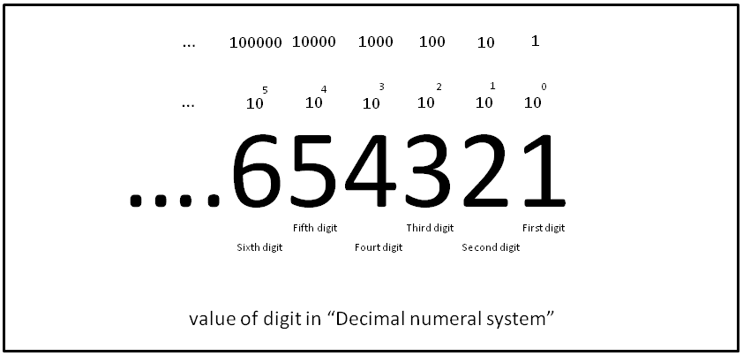

As each place value moves one to the left, the power of ten is increased by 1. The units column is 100, the tens, 101, the hundreds, 102 and so on.

## **Binary Numbers:**

The place value columns in the binary table below are powers of 2. The only valid digits to use are 1 and 0. We call these bits. Just like in the denary table, we add up the results of multiplying each number in the table by its place value.

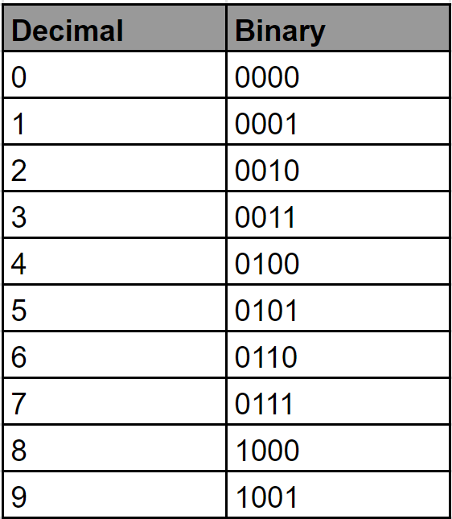

## **Binary Addition:**

Addition using binary numbers is relatively straightforward. The following rules need to be observed,

* 0 + 0 = 0
* 0 + 1 = 1 + 0 = 1
* 1 + 1 = 10 (0, carry 1)
* 1 + 1 + 1 = 11 (1, carry 1)

In the following example, the binary numbers, 1011 (11 in denary) and 10010 (18 in denary) are added together.

